Q.1)→ Write a program to add number of days to a given date. The program must accept date from user in the format dd-mm-yyyy. The date after adding number of days must also be displayed in the format dd-mm-yyyy.

#include <iostream>
using namespace std;

int main ()
{
int n,dd,mm,yy;

cin>>dd>>mm>>yy;
cin>>n;
dd=dd+n;

if (mm==1||mm==3||mm==5||mm==7||mm==8||mm==10||mm==12)
{ if(dd==31||dd>31)
{
mm++;
dd=dd-31;

}
}

else if (mm==2)
{ if (dd==28||dd==29||dd>29)
{
mm++;
dd=dd-28;
}
}
else if ((mm==4)||(mm==6)||(mm==9)||(mm==11))
{ if(dd>30)
{mm++;
dd=dd-30;
}
}
else if(dd>31)
{mm++;
dd=dd-31;

}

else if(mm>12)
{yy++;
mm=mm-12;
}
else
cout<<"error";

cout << "NEW DATE: " << dd << "/" << mm<< "/" << yy << endl;
}
OUUTPUT→

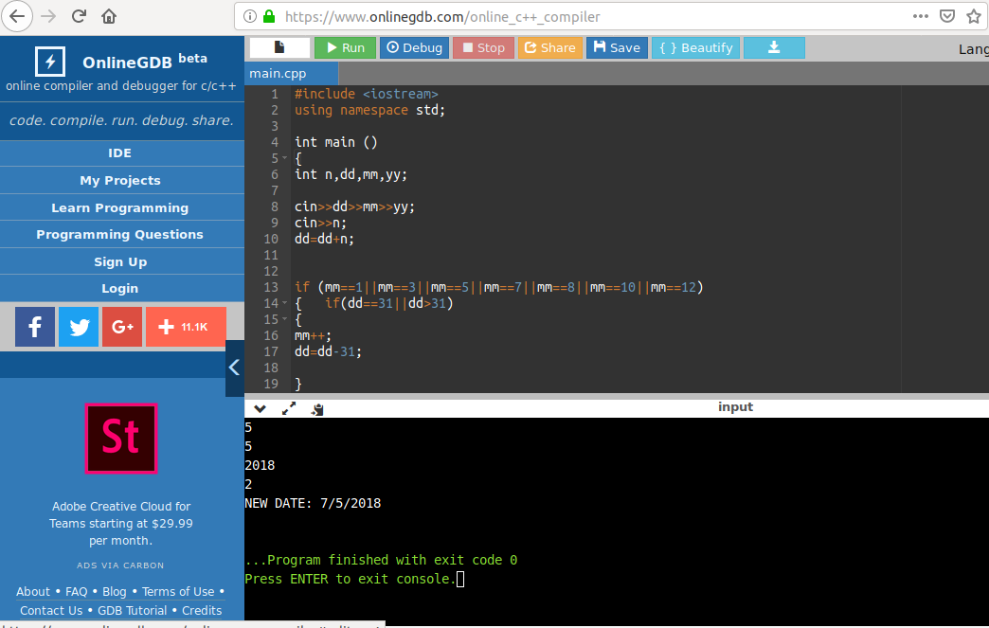
Q2) Write a program to calculate the age of the person is number of years and days. The program takes birthdate as input and calculates the age of a person as on 1/4/2019.

#include<iostream>
using namespace std;
class date
{int days, months, year;
public:
void input()
{cout<<"enter day month year: ";
cin>>days>>months>>year;
}
friend date age(date d1);
void output()
{
cout<<"age on 1/4/2019= "<<year<<" years "<<months<<" months "<<days<<" days.";
}
};
date age(date d1)
{
date d3;
d3.year=2019-d1.year;
if(d1.months>4)
{
d3.months=12-d1.months+4;
d3.year--;
}
else
d3.months=4-d1.months;
d3.days=31-d1.days+1;
d3.months--;
return d3;
}

int main()
{
date d2, a;
d2.input();
a=age(d2);
a.output();
return 0;
}

OUTPUT→

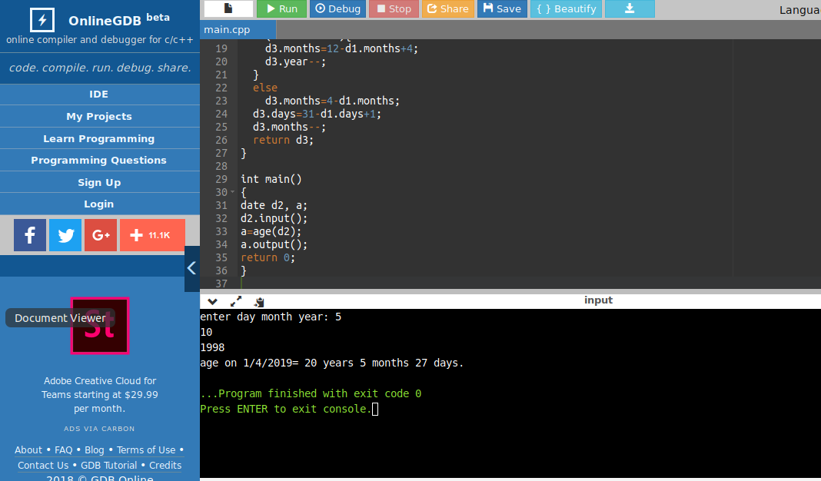

Q3)
a)→ Create a structure called time. Its three members, all type int, should be called hours, minutes, and seconds. Write a program that prompts the user to enter a time value in hours, minutes, and seconds. This can be in 12:59:59 format, or each number can be entered at a separate prompt (“Enter hours:”, and so forth). The program should then store the time in a variable of type struct time, and finally print out the total number of seconds represented by this time value:
long total secs = t1.hours*3600 + t1.minutes*60 + t1.seconds

#include <iostream>
using namespace std;
struct time
{
int hr, min, sec;
void input()
{
cout<<"hr,min,sec: ";
cin>>hr>>min>>sec;
}
long totalsec()
{
return hr*3600+min*60+sec;
}
void convert( long tsec)
{
hr=tsec/3600;
tsec=tsec%3600;
min=tsec/60;
sec=tsec%60;
}
void output()
{
cout<<"hr: "<<hr<<" min: "<<min<<" sec: "<<sec;
}
};
struct time add(struct time t1, struct time t2)
{
struct time t3;
long tsec;
tsec=t1.totalsec()+t2.totalsec();
t3.convert(tsec);
return t3;
}

int main()
{
struct time t1, t2, t3;
t1.input();
t2.input();
t 3=add(t1,t2);
t3.output();
return 0;
}
OUTPUT→
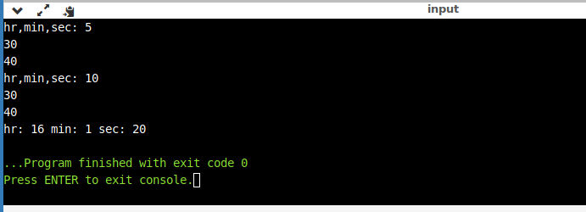
b)→ Use the time structure and write a program that obtains two time valuesfrom the user in 12:59:59 format, stores them in struct time variables, converts
each one to seconds (type int), adds these quantities, converts the result back to hoursminutes- seconds, stores the result in a time structure, and finally displays the result in 12:59:59 format.

#include <iostream>
using namespace std;
struct time
{
int hr, min, sec;
void input()
{
cout<<"hr,min,sec: ";
cin>>hr>>min>>sec;
}
long totalsec()
{
return hr*3600+min*60+sec;
}
void convert( long tsec)
{
hr=tsec/3600;
tsec=tsec%3600;
min=tsec/60;
sec=tsec%60;
}
void output()
{
cout<<"hr: "<<hr<<" min: "<<min<<" sec: "<<sec;
}

};
struct time add(struct time t1, struct time t2)
{
struct time t3;
long tsec;
tsec=t1.totalsec()+t2.totalsec();
t3.convert(tsec);
return t3;
}

int main()
{
struct time t1, t2, t3;
t1.input();
t2.input();
t3=add(t1,t2);
t3.output();
return 0;
}
OUTPUT→
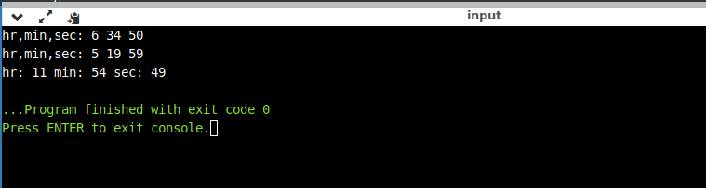

Q4) → Imagine a tollbooth at a bridge. Cars passing by the booth are expected to pay a 50 cent toll. Mostly they do, but sometimes a car goes by without paying. The tollbooth keeps track of the number of cars that have gone by, and of the total amount of money collected. Model this tollbooth with a class called tollBooth. The two data items are a type unsigned int to hold the total number of cars, and a type double to hold the total amount of money collected. A constructor initializes both of these to 0. A member function called payingCar() increments the car total and adds 0.50 to the cash total. Another function, called nopayCar(), increments the car total but adds nothing to the cash total. Finally, a member function called display() displays the two totals. Make appropriate member functions const.
Include a program to test this class. This program should allow the user to push one key to count a paying car, and another to count a nonpaying car. Pushing the Esc key should cause the program to print out the total cars and total cash and then exit.

#include<iostream>
#include<conio.h>
using namespace std;
class tollbooth
{unsigned int coun;
double money;
public:
tollbooth()
{coun=0;
money=0;
}
void payingcar()
{coun=coun+1;
money=money+0.50;
}
void nopaycar()
{coun=coun+1;
}
display()
{cout<<"The total cars : "<<coun<<"\n and The total money is :"<<money;
}
};
int main()
{clrscr();
tollbooth t1;
int y;
cout<<"select case\n 1.paying car \n 2. non paying car \n 3. display";
while(y!=3)
{
cin>>y;
switch(y)
{
case 1:{
t1.payingcar();
break;
}
case 2:{
t1.nopaycar();
break;
}
case 3:{
t1.display();
break;
}
}
}
}

OUTPUT→
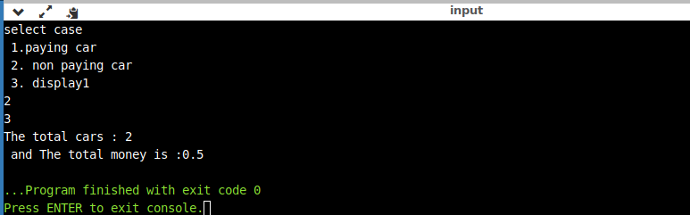
Q5)
→ Write C++ program to overload a function named power( ) to allow the calculation of power of
both ‘int’ and ‘float’ value.

#include<iostream>
#include<conio.h>
#include<math.h>
#include<stdlib.h>
using namespace std;
int power(int n, int r)
{
int x;
x=pow(n,r);
return x;
}
float power(float m, int s)
{
float y;
y=pow(m,s);
return y;
}
int main()
{
clrscr();
int a, b;
float c;
char ch;

cout<<"Enter 1 if you want to calculate the power of an integer "<<endl;
cout<<"Enter 2 if you want to calculate the power of a floating number"<<endl;
cin>>ch;
switch(ch)
{
case '1': cout<<"Enter the integer and the exponent"<<endl;
cin>>a>>b;
cout<<power(a,b);
break;
case '2': cout<<"Enter the floating number and the exponent"<<endl;
cin>>c>>b;
cout<<power(c,b);
break;
default :if((ch!='1')&&(ch!='2'))
{
cout<<"Wrong choice entered "<<endl;
}

}
getch();
}

OUTPUT→
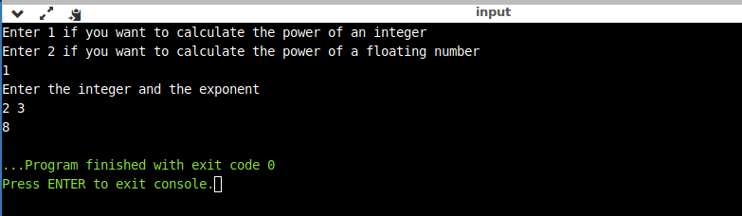
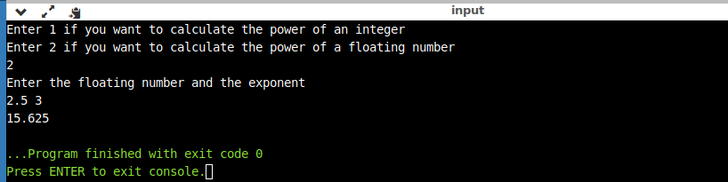
Q6)→
Create a class called time. Its three members, all type int, should be called hours, minutes, and seconds. One constructor should initialize this data to 0., and another to fixed values. A member function should display it in 12:59:59 format. The final member function should add two objects of type time passed as arguments. A main( ) program should create two initialised time objects, and one is not initisalised. Them it should add two initialised values together, leaving the result in the third time variable. Finally it should display the result of this third variable

#include<iostream>
using namespace std;
class time
{
int hours;
int minutes;
int seconds;
public:
time()
{
hours=0;
minutes=0;
seconds=0;
}
time(int h, int m, int s)
{
hours=h;
minutes=m;
seconds=s;
}
void display()
{
cout<<"Time:"<< hours<<":"<< minutes<<":"<< seconds<<"\n";
}
time add(time t1, time t2)
{
time t3;
t3.hours=t1.hours+t2.hours;
t3.minutes=t1.minutes+t2.minutes;
t3.seconds=t1.seconds+t2.seconds;
if(t3.seconds>=60)
{
int ss=t3.seconds/60;
t3.minutes=t3.minutes+ss;
t3.seconds=t3.seconds-(ss*60);
}
if(t3.minutes>=60)
{
int mm=t3.minutes/60;
t3.hours=t3.minutes+mm;
t3.minutes=t3.minutes-(mm*60);
}
if(t3.hours>=12)
{
int yy=t3.hours/24;
t3.hours=t3.hours-(yy*12);
}
return t3;
}
};
int main()
{
time t1(6,6,2);
time t2(7,4,2);
t1.display();
t2.display();
time t3;
t3=t3.add(t1, t2);
t3.display();
}

OUTPUT→

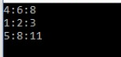

Q7)→ Modify the time class so that instead of add_time function it uses the overloaded + operator to add two times.

#include<iostream>
using namespace std;
class time
{
int hours;
int minutes;
int seconds;
public:
time()
{
hours=0;
minutes=0;
seconds=0;
}
time( int h, int m, int s)
{
hours=h;
minutes=m;
seconds=s;
}
void display()
{
cout<<"Time:"<< hours<<":"<< minutes<<":"<< seconds<<"\n";
}
friend time operator+(time,time);
};
time operator+(time t1, time t2)
{
time t3;
t3.hours=t1.hours+t2.hours;
t3.minutes=t1.minutes+t2.minutes;
t3.seconds=t1.seconds+t2.seconds;
return t3;
}
int main()
{
time t1(3,5,2);
time t2(4,2,1);
t1.display();
t2.display();
time t3;
t3=t1+t2;
t3.display();
}
OUTPUT→
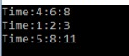

Q10)→
Write a program to declare two classes Rupees and Dollar. Declare objects of both the classes and perform conversion between Rupees and Dollar using any of the conversion method.

#include<iostream>
#include<conio.h>
using namespace std;
class rupees
{
float amount;
float rate;
public:
rupees()
{
amount=0;
rate=0;
}
rupees(int a)
{
amount=a;
}
void convertrupees(float r)
{
rate=r;
amount=amount*(1/rate);
cout<<amount<<"#";
}
};
class dollars
{
float amount;
float rate;
public:
dollars()
{
float amount=0;
float rate=0;
}
dollars(int a)
{
amount=a;
}
void get()
{cout<<"enter the amount in dollars:\t";
cin>>amount;
cout<<"enter the conversion rate of dollar into inr:\t ";
cin>>rate;
}
void convertdollars()
{
amount=amount*rate;
}
void show()
{cout<<amount<<"$";
}
};
int main()
{
clrscr();
cout<<"what do you like to convert\n 1.dollars\n 2.rupees\n";
int x;
cin>>x;
switch(x)
{
case 1:{
dollars d1;
d1.get();
d1.convertdollars();
d1.show();
break;
}
case 2:{
cout<<"enter the amount in rupees: \t";
int a;
cin>>a;
rupees r1(a);
int r;
cout<<"enter the conversion rate of dollars into inr:\t";
cin>>r;
r1.convertrupees(r);
break;
}
}

}

OUTPUT→

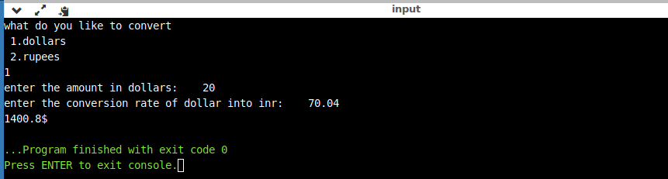

Q11)→
.1)→ Create a class Country, State, City and Village and arrange them in hierarchical manner.

#include<iostream>
using namespace std;
class country
{
protected:
char a[10];
public:
void getc()
{
cout<<"Enter the country name"<<endl;
cin>>a;
}
void showc()
{
cout<<a;
}
};
class state:public country
{
protected:
char b[10];
public:
void gets()
{
cout<<"Enter the state name"<<endl;
cin>>b;
}
void shows()
{
cout<<b;
}
};
class city:public state
{
protected:
char c[10];
public:
void getci()
{
cout<<"Enter the city name"<<endl;
cin>>c;
}
void showci()
{
cout<<c;
}
};
class village:public city
{
protected:
char d[10];
public:
void getv()
{
cout<<"Enter the village name"<<endl;
cin>>d;
}
void showv()
{
cout<<d;
}
};
int main()
{
village z;
z.getv();
z.getci();
z.gets();
z.getc();
cout<<"the info goes as follows:"<<endl;
cout<<"village--->"; z.showv(); cout<<endl;
cout<<"city--->";z.showci();cout<<endl;
cout<<"state--->";z.shows();cout<<endl;
cout<<"country--->";z.showc();cout<<endl;
return 0;
}
OUTPUT →
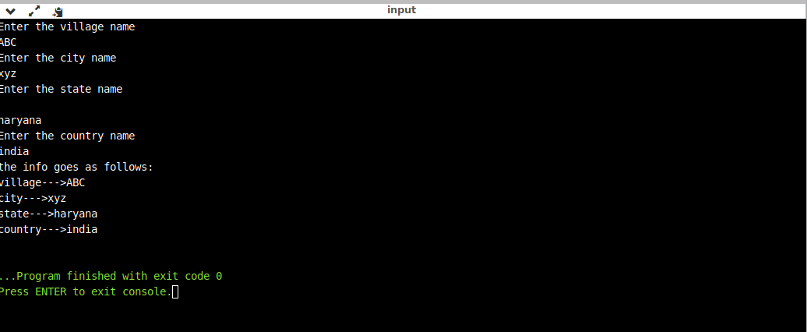
2)→ Declare a class Vehicle. From this class derived two_wheeler, three_wheeler and four_wheeler class. Display properties of each type of vehicle using member function of the class.

#include<iostream>
using namespace std;
class vehicle
{
public:
void vehicles()
{
cout<<"Vehicles are important for human world they helps in easy transportaition and travelling"<<endl;
}
void vehicles_intro()
{
cout<<"this vehicle type is"<<endl;
}
};
class two_wheeler : public vehicle
{
public:
void two_wheeler1()
{
cout<<"Two Wheeler"<<endl<<"Mostly Motorcycles, Bicycle"<<endl<<"-->Samaller engines \n-->Smaller fuel tanks\n--> average speed"<<endl;
}
};
class three_wheeler : public vehicle
{
public:
void three_wheeler1()
{
cout<<"Three Wheeler"<<endl<<"Mostly Autosmated Rikshaws "<<endl<<"-->Samaller engines \n-->specialised fuel tanks\n--> slow moving with less top speed"<<endl;
}
};
class four_wheeler : public vehicle
{
public:
void four_wheeler1()
{
cout<<"Four Wheeler"<<endl<<"Cars, Vans, busses"<<endl<<"-->relatively larger engines \n-->big fuel tanks\n--> good top speed"<<endl;
}
};
int main()
{
two_wheeler a;
a.vehicles();
a.vehicles_intro();
a.two_wheeler1();
three_wheeler b;
b.vehicles_intro();
b.three_wheeler1();
four_wheeler c;
c.vehicles_intro();
c.four_wheeler1();
return 0;
}

OUTPUT→
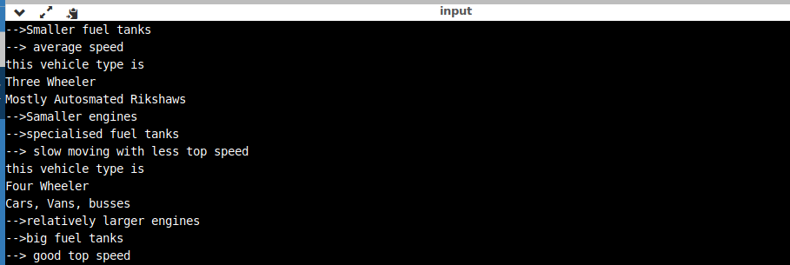
3) →3. Write a program to declare classes A, B and C. Each class contains one char array as a data member. Apply multiple inheritances. Concatenate strings of class A and B and store it in class C.

#include<iostream>
#include<string>
using namespace std;
class a
{
public:
string s1;
public:
void geta()
{
cout<<"Enter the string"<<endl;
getline(cin,s1);
}
};
class b
{
public:
string s2;
public:
void getb()
{
cout<<"Enter the string"<<endl;
getline(cin,s2);
}
};
class c: public a,public b
{
public:
string s3;
public:
void get()
{
s3 = s1 + s2;
}
void show()
{
cout<<endl<<s3<<endl;
}
};
int main()
{
c z;
z.geta();
z.getb();
z.get();
cout<<"After concatinating"<<endl;
z.show();
return 0;
}

OUTPUT→
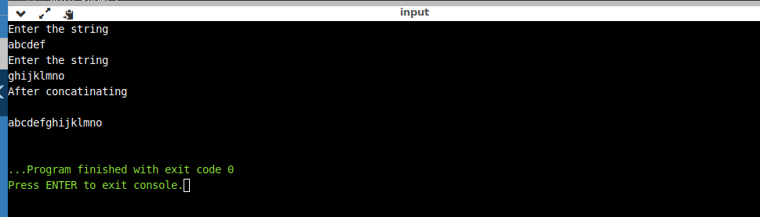

4)→ Imagine a publishing company that markets both book and audiocassette versions of its works.
Create a class publication that stores the title (a string) and price (type float) of publication. From this class derive two classes : book, which adds a page count (type int); and tape, which adds a playing time in minutes (type float). Each of these three classes should have a getdata ( ) function to get its data from the user at the keyboard and a putdata ( ) function to display its data.
Write a main( ) program to test the book and tape classes by creating instance of them, asking the user to fill in data with getdata( ) and then displaying data with putdata( ).

#include<iostream>
using namespace std;

class publication
{
public:
char title[15];
float price;
void getdata()
{
cout<<"enter the title"<<endl;
cin>>title;
cout<<endl<<"enter the price"<<endl;
cin>> price;
}
void showdata()
{
cout<<"title is "<<title<<endl;
cout<<"price is "<<price<<endl;
}
};
class book: public publication
{
public:
int page_count;
public:
void getdata()
{
cout<<"enter the no. of pages in book "<<endl;
cin>>page_count;
}
void showdata()
{
cout<<"No. of pages in book are "<<page_count<<endl;
}
};
class tape: public publication
{
public:
int playing_time;
public:
void getdata()
{
cout<<"enter the palying time in minutes "<<endl;
cin>>playing_time;
}
void showdata()
{
cout<<"total play time of the tape is "<<playing_time<<endl;
}
};
int main()
{
cout<<"Book"<<endl;
book a;
a.publication::getdata();
a.publication::showdata();
a.getdata();
a.showdata();
cout<<endl<<"tape"<<endl;
tape b;
b.publication::getdata();
b.publication::showdata();
b.getdata();
b.showdata();
return 0;
}
OUTPUT→
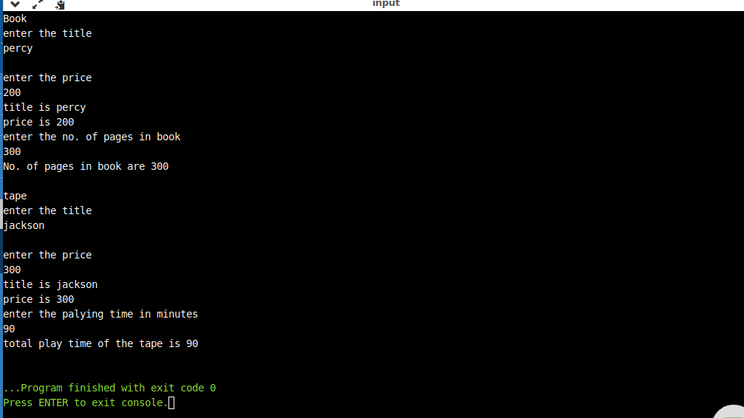
5)→ Start with the publication, book and tape classes of Exercise-4. Add a base class sales that holds an array of three floats so that it can record the dollar sales of a particular publication for the last three months. Include a getdata ( ) function to get three sales amounts from the user and a putdata ( ) function to display the sales figures. After the book and tape classes so they are derived from both publication and sales. An object of class book or tape should input and output sales data along with its other data. Write a main ( ) function to create a book object and a tape object and exercise their input/output capabilities.

#include<iostream>
using namespace std;

class publication
{
public:
char title[15];
float price;
void getdata()
{
cout<<"enter the title"<<endl;
cin>>title;
cout<<endl<<"enter the price"<<endl;
cin>> price;
}
void showdata()
{
cout<<"title is "<<title<<endl;
cout<<"price is "<<price<<endl;
}
};
class sales: public publication
{
public:
float s[20];
int i;
void getdata()
{
cout<<"Enter the data of sales of 3 months in dollars"<<endl;
for(i = 0; i<3; i++)
{
cin>>s[i];
}
}
void showdata()
{
cout<<"the sale for past 3 months"<<endl;
for(i= 0; i<3 ; i++)
{
cout<<s[i]<<endl;
}
}
};
class book: public sales
{
public:
int page_count;
public:
void getdata()
{
cout<<"enter the no. of pages in book "<<endl;
cin>>page_count;
}
void showdata()
{
cout<<"No. of pages in book are "<<page_count<<endl;
}
};
class tape: public sales
{
public:
int playing_time;
public:
void getdata()
{
cout<<"enter the palying time in minutes "<<endl;
cin>>playing_time;
}
void showdata()
{
cout<<"total play time of the tape is "<<playing_time<<endl;
}
};
int main()
{
cout<<"Book"<<endl;
book a;
a.publication::getdata();
a.publication::showdata();
a.sales::getdata();
a.sales::showdata();
a.getdata();
a.showdata();
cout<<endl<<"tape"<<endl;
tape b;
b.publication::getdata();
b.publication::showdata();
b.sales::getdata();
b.sales::showdata();
b.getdata();
b.showdata();
return 0;
}

OUTPUT→
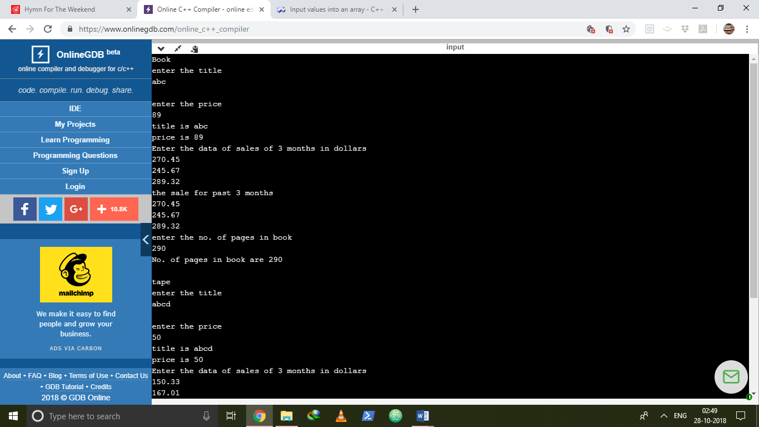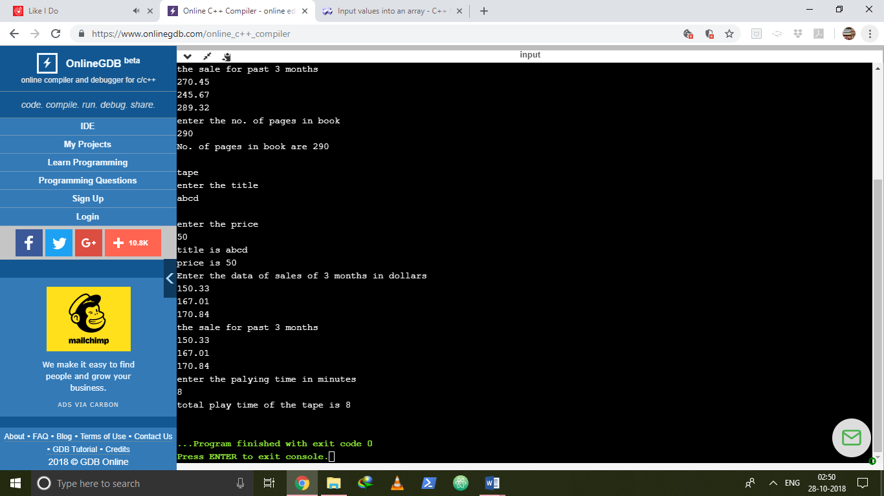

6)→ Derive a class called employee2 from the employee class. This new class should add a type double data item called compensation and, also an enum type called period to indicate whether the employee is paid hourly, weekly, or monthly. For simplicity you can change the manager, scientist and labourer classes so they are derived from employee2 instead of employee. However, note that in many circumstances it might be more in the spirit of OOP to create a separate base
class called compensation and three new class manager2, scientist2 and labour2 and use multiple inheritances to derive these classes from the original manager, scientist and labourer classes and from compensation. This way none of the original classes needs to be modified

#include <iostream>
using namespace std;

const int LEN = 80;

class employee
{
private:
char name[LEN];
unsigned long number;
public:
void getdata()
{
cout << "\n Enter last name : "; cin >> name;
cout << " Enter number :"; cin >> number;
}
void putdata() const
{
cout << "\n Name : " << name;
cout << "\n Number : " << number;
}
};

class employee2 :public employee
{
private:
double compen;
enum paytype{ hourly, weakly, monthly };
paytype period;
public:
void getdata(void)
{
char a;
employee::getdata();
cout << "Enter compensation: ";
cin >> compen;
cout << "Enter payment period (h,w,m): ";
cin >> a;
switch (a)
{
case 'h':
period = hourly;
break;
case 'w':
period = weakly;
break;
case 'm':
period = monthly;
break;
}
}
void putdata(void) const
{
employee::putdata();
cout << "Employee compensation: " << compen << endl;
switch (period)
{
case hourly:
cout << "hourly" << endl;
break;
case weakly:
cout << "weakly" << endl;
break;
case monthly:
cout << "monthly" << endl;
break;
}
}
};

class manager : public employee2
{
private:
char title[LEN];
double dues;
public:
void getdata()
{
employee2::getdata();
cout << " Enter title : "; cin >> title;
cout << " Enter golf club dues : "; cin >> dues;
}
void putdata() const
{
employee2::putdata();
cout << "\n Title : " << title;
cout << "\n Golf club dues : " << dues;
}
};

class scientist : public employee2
{
private:
int hotels;
public:
void getdata()
{
employee2::getdata();
cout << " Enter number of hotels : "; cin >> hotels;
}
void putdata() const
{
employee2::putdata();
cout << "\n Number of publications : " << hotels;
}
};

class laborer : public employee2
{};

int main()
{
manager m1, m2;
scientist s1;
laborer l1;
cout << endl;
cout << "\nEnter data for manager 1";
m1.getdata();
cout << "\nEnter data for manager 2";
m2.getdata();
cout << "\nEnter data for scientist 1";
s1.getdata();
cout << "\nEnter data for laborer 1";
l1.getdata();

cout << "\nData on manager 1";
m1.putdata();
cout << "\nData on manager 2";
m2.putdata();
cout << "\nData on scientist 1";
s1.putdata();
cout << "\nData on laborer 1";
l1.putdata();
cout << endl;
return 0;
}

OUTPUT→

